Analysis Document 1

Carrot Quest✅

“Ari”

- Introduction 3-6 pgs
- Overview 4 pgs
- additional task
- project leader
Make sure project is completed within timeframe
schedule work and times for what needs to be in when
Editor: Putting total document together making sure it flows together

“Jimmy”

- Functional requirements 4 pgs ✅
- Nonfunctional requirements 4 pgs ✅
- Additional tasks
  - Creating detailed “mock-up” of the game✅

“Steven & Adan”

(making models & simple bullets
vs. writing descriptions of the models)

- System models 2 models 1 written page
- Use case model 3 models 1 written page
- Dynamic models 3 models 2 written pages
- Object and class model 2-4 models 1-2 written pages
- User interface - navigational paths and screen mock-ups 1 image 1 written page
- Additional task
- Bullet description of models for writers to write in detail.

“Jugraj”

- Conclusion 1 page
- Contributions 2 pages
- Glossary & references 1 page
- Additional tasks
- (2nd Editor: Putting total document together making sure it flows together)
Team Effort Check After completion for everyone

Introduction

Overview

Functional and Non-Functional Requirements

Functional Requirements
User Interface (UI)
"Carrot Quest" is designed to have a user-friendly interface that enhances the player's gaming experience. The playful aesthetic, coupled with intuitive navigation, ensures that players can easily interact with the game’s features.
Text and Style
· The game's font is written in 'Bubblegum Sans' to create a fun and inviting atmosphere for the player.
· Bright, engaging color schemes are used to keep the game visually appealing, with shades of deep pink, white, and light pink forming the core design palette.

Start Screen
Main Menu Screen
· A visually appealing field themed background (Menu_Screen.png) sets the tone for the game from the start.
Interactive Elements
· The main menu contains three buttons: "Play," "Instructions," and "High Scores."
· The game title features a lively bouncing animation, further immersing players in the playful design.
Instructions Screen
· Players can access the instructions screen via the "Instructions" button on the main menu.
· The background image (instruction_background.png) is designed to fit the playful yet informative tone of the game.
· Instructions are concise, providing players with all necessary gameplay mechanics in an easy-to-understand format.
High Scores Screen
· This screen is accessible from the main menu and displays a list of the top scores achieved by players.
· The background (High_Score_Background.png) complements the rest of the game's visual identity, ensuring continuity across different screens.

Game Canvas
Primary Gameplay Area
· The game canvas is designed to utilize the full width and height of the browser window, giving players a fully immersive experience.
· A themed background (CarrotQuestBackground.mp4) enhances the overall atmosphere of the game allowing for visual aesthetic and supports the game's progression.
Game Over Screen
· This screen appears when the game ends due to either a collision with an obstacle or falling off the screen.
· The background (GameOver_Screen.png) is consistent with the game's overall visual theme.
· The player’s final score is displayed prominently, with buttons for restarting the game or returning to the main menu.

Gameplay Mechanics
Rabbit Character
· Players control a charming rabbit character, the main protagonist of the game.
· The rabbit has two distinct visual states: facing right (rabbit-right.png) and facing left (rabbit-left.png).
· The character is set to a fixed size of 100x100 pixels, ensuring consistent interaction with the game world.
Movement and Physics
· Players move the rabbit horizontally using the arrow keys or 'A' and 'D' keys.
· The game incorporates realistic physics, with gravity and jumping mechanics affecting the vertical movement of the rabbit.
· The rabbit can wrap around the screen horizontally, adding an additional layer of strategic gameplay.
Platforms
· Platforms are randomly generated and move downwards as the rabbit ascends higher.
· This kind of dynamic generation for the platforms appearing improves the quality of gameplay by adding additional motion.
· Each platform is sized at 450x250 pixels and uses the platform.png image to maintain consistency with the overall design.

Obstacles
Bombs
· Bombs serve as obstacles scattered throughout the game.
· If the rabbit collides with a bomb, the game immediately ends, emphasizing the need for careful navigation.
Scoring System
· Real-Time Score Calculation
· Players earn points as they ascend higher in the game, with the score being updated in real-time.
· The scoring mechanism is based on the height reached by the player, encouraging continued progression.

Game States
Menu State
· Initial State
· The game begins in the menu state, allowing players to navigate between the main menu, instructions, and high scores screens.
Playing State
· Active Gameplay
· This state is activated once the player starts the game. The game runs in a continuous loop, updating game elements like character movement, platform generation, and obstacle appearance.
Game Over State
· End of Game
· Triggered when the rabbit collides with a bomb or falls off the screen, this state displays the final score and options for restarting or returning to the main menu.

User Interactions
Menu Navigation
· Simple Navigation for ease of use to a new player.
· Players can navigate between screens (main menu, instructions, high scores) by clicking the appropriate buttons.

Gameplay Controls
Keyboard Inputs
· During gameplay, players use the keyboard to control the rabbit’s movement.
· The game actively listens for key down and key up events to provide responsive gameplay.

Restart and Return to Menu
· These are options provided below the score on the game over screen
· After a game is over, players are presented with options to either restart the game or return to the main menu, allowing for seamless gameplay.

Non-Functional Requirements
Performance
· Frame Rate and Smoothness
· Animation Handling
· The game uses the requestAnimationFrame method for smooth animations and optimal performance, ensuring that gameplay remains fluid across devices.
Resource Management
· Image Preloading
· All necessary images are preloaded to avoid any in-game delays, ensuring that the player’s experience remains uninterrupted by technical glitches.
Scalability
· Dynamic Canvas Sizing
· Responsive Design
· The game canvas automatically adjusts to fit the full width and height of the browser window, making the game adaptable to different screen sizes and resolutions.
Adaptive Difficulty
· Progressive Challenge
· The game’s difficulty can be dynamically adjusted to gradually increase as the player progresses, ensuring a challenging experience for both beginners and seasoned players.
Usability
· Intuitive Controls
· Familiarity
· The game leverages standard arrow keys and WASD controls to make gameplay intuitive for players familiar with common platform games.

Visual Feedback
Directional Feedback
· The rabbit’s sprite changes direction based on player inputs, providing clear and immediate visual feedback during gameplay.
Accessibility
· Color Scheme
Visibility
· The game uses a high-contrast color scheme to ensure visibility for all players, including those with visual impairments.
Audio Cues
· Future Expansion
· Not currently implemented, the game’s design allows for the addition of audio cues and feedback, which could enhance the experience for players with hearing impairments.
Maintainability
· Modular Code Structure
· Code Organization
· The game’s JavaScript code is organized into modular functions, ensuring maintainability and ease of updates.
CSS Styling
· Separation of Concerns
· Visual elements are handled via a separate CSS file, allowing for streamlined design updates without affecting the core game logic.
Compatibility
· Cross-Browser Support
· Browser Agnostic
· The game is built using standard web technologies (HTML5, CSS3, and JavaScript), ensuring compatibility across all modern browsers.
Mobile and Desktop Support
· The game is designed to function seamlessly on both desktop and mobile platforms, with controls that can be adapted for touch-based input on mobile devices.
Security
· Input Sanitization
· Preventing Exploits
· Input sanitization is necessary, particularly for handling high score submissions to prevent malicious inputs or tampering with scores.
Localization
· Text Externalization
· Language Support
· The game’s text content can be externalized, allowing for easy localization into multiple languages, expanding its reach to global audiences.

System Models

Use Case Models

Sequence & Dynamic Models

Objects & Class Models

User Interface
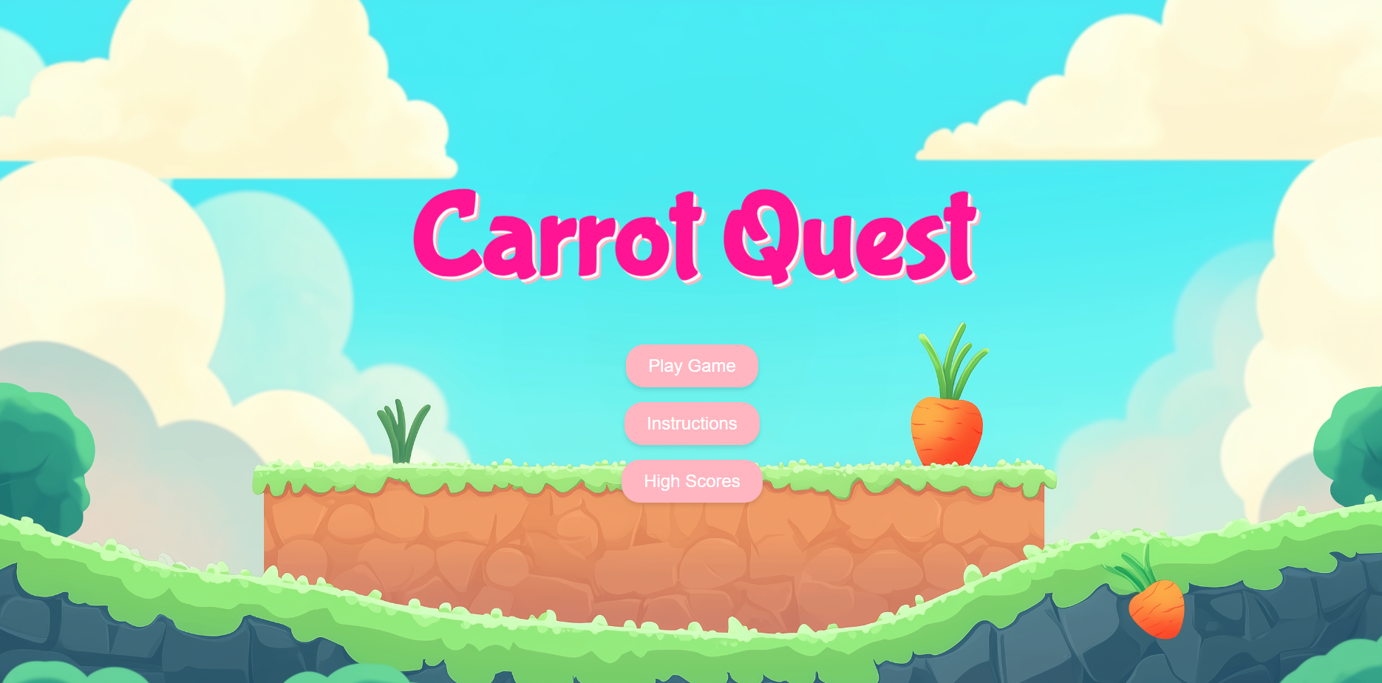

Conclusion

Contributions

Glossary & References

